**Test Case 8 – Sloping Slab on Grade**

*Test Description* : A three-zone model mimicking a small auditorium has been created, where the floor slopes as may be seen in architectural practice. Consumers of gbXML had voiced concerns over this test case, stating gbXML did not work well in this case. The space itself is a large, multi-story space with a pitched roof, for improved acoustical performance

*Space Names:* This is important because the gbXML validator requires the strings in the test file match the standard file. The name check is case sensitive. Ensure that the id attribute of the Space elements in the gbXML test file match the standard file space names shown below.

|  |  |  |
| --- | --- | --- |
| Standard File Space Name | Test File Space Name | Verified |
| sp-1-Occupied_Auditorium |  |  |
| sp-2-Unoccupied_Auditorium |  |  |
| sp-3-Roof_Void |  |  |

*Special Considerations:*

1. There are underground walls in this model
2. A surface of surfaceType=”Air” is used in this model, which represents the dividing partition between sp-1-Occupied_Auditorium and sp-2-Unoccupied_Auditorium.

*Complexity of the BIM Model:*

1. Simple planar surfaces orthogonal to the project Cartesian reference frame.
2. Simplified walls with no visible layers.
3. Simple details at interfaces of surfaces.
4. Egg shell models can be tested in this example.

*Description of Test:*

Figure 1 shows a simple 3D axonometric view of how the example is massed. It can be loosely observed, but clarified here, that the floor slab and roof do slope in one direction, along a global reference frame axis (-X). The slab starts at grade on the east side of the building, and then descend below grade. Thus, the walls that are attached to the slab as it descends are underground walls. Figure 2 shows this more clearly. It also shows details of some important geometry information regarding the heights of spaces and the thickness of different roof and floor assemblies.

Figure 3 goes on to show the dimensions of a typical project floor plate for each one of the spaces listed above. This is the only floor plan shown because all three spaces in the project have the exact same X-Y dimensions. It is only Z that varies.

Figure 4 shows a roof plan and the region where the roof changes slope..

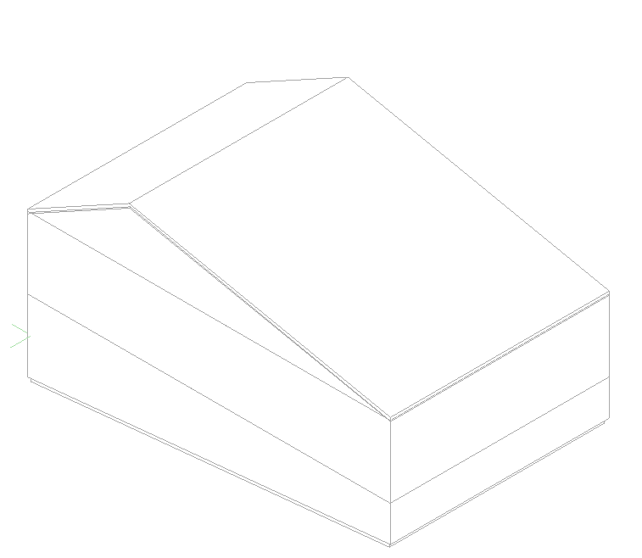

Figure : Test case 7 shown in an axonometric view to reveal the simple sloping roof and floor way. The slab on grade starts at grade and then sinks below grade (1ft drop for every 10ft horizontally).

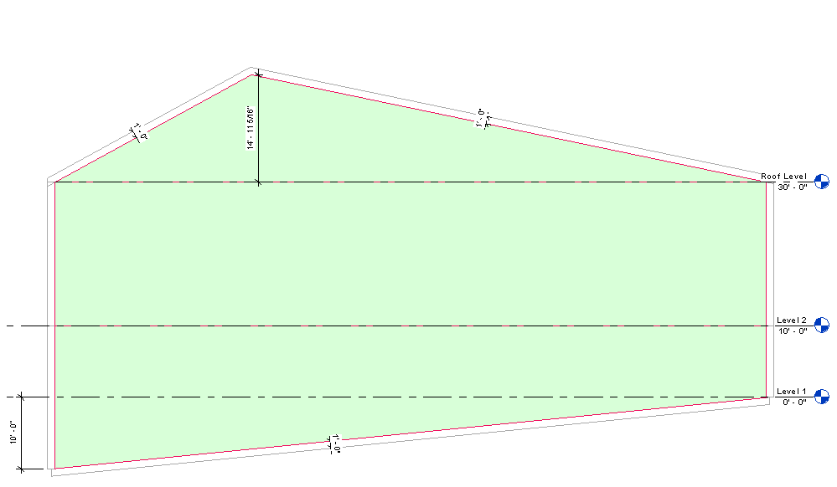

sp-3

sp-1

sp-2

Figure : Section looking north , showing the different spaces and their assignemt to this Test Case. Also details of dimensions are highlighted.

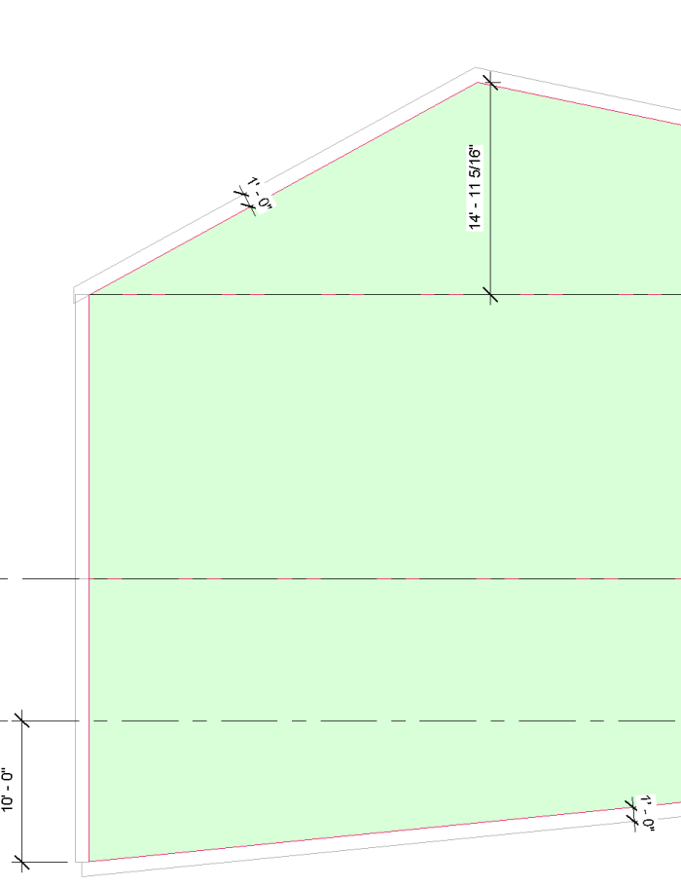

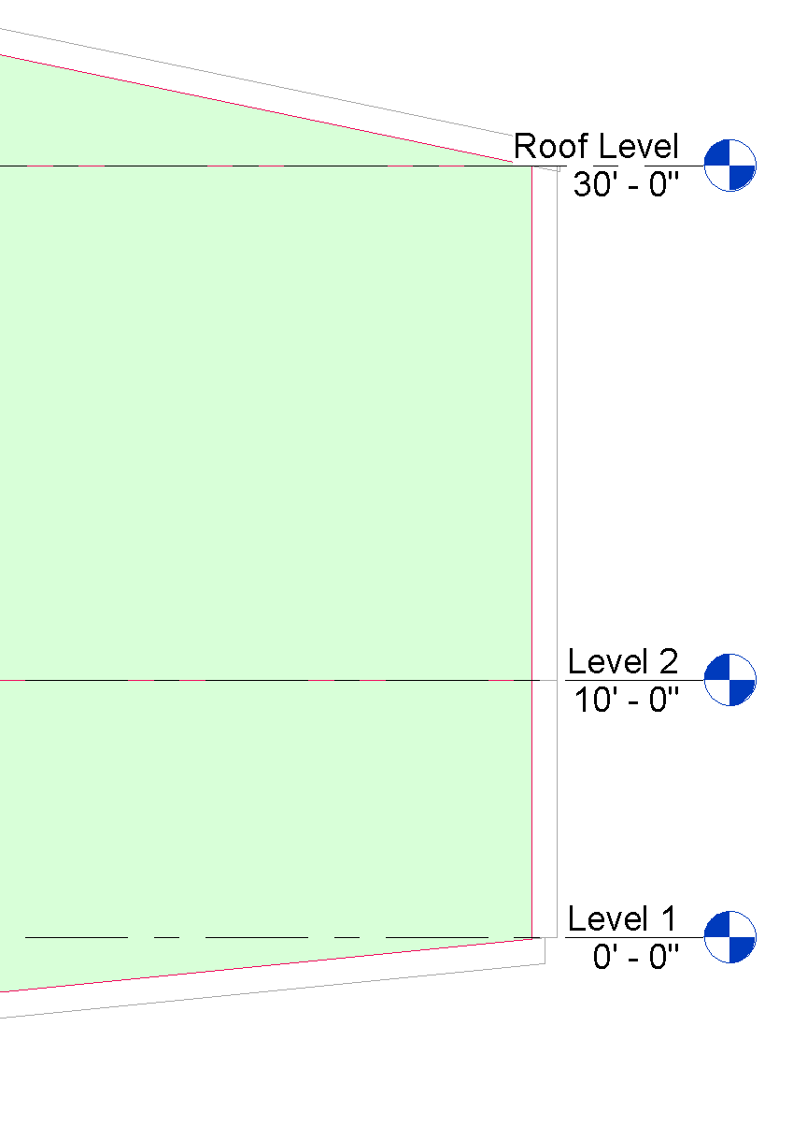

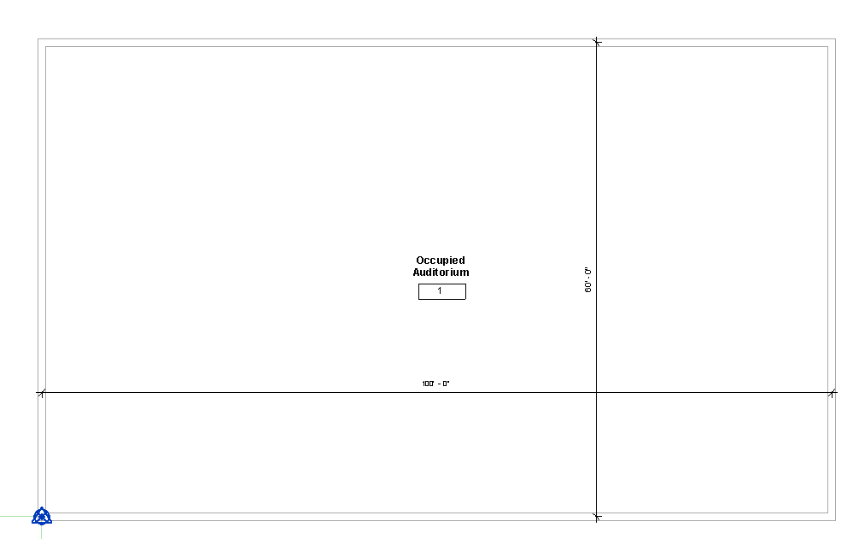

Figure : The first floor of the auditorium plan view (the location of the occupied portion of the space. The dimensions are 100’ centerline to centerline E-W, and 60’ centerline to centerline N-S.

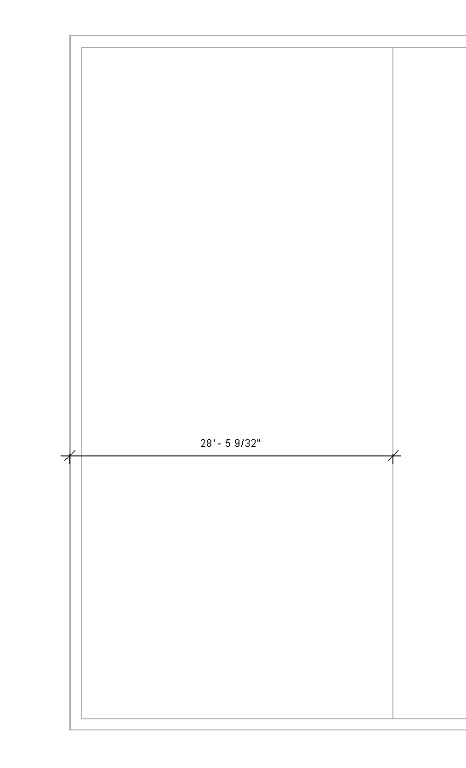

Figure : The roof...showing the distance from the origin's X-Axis to the roof apex, where it reverses slope.

|  |  |  |  |
| --- | --- | --- | --- |
| Surface Description | Surface Thickness | Surface Type | Comments |
| Exterior Wall | 12” | n/a |  |
| Roof | 12” | n/a |  |
| Interior Floor Slab | 12” | n/a |  |

Table : Dimensions and descriptions of wall elements in Test Case 8.

*Example of the gbXML Code Relevant to this Example*

This test case will have no very unique cases that will require deep explanation, and all information about this test case can be found in the gbXML Implementation Guide.